TABLE OF CONTENT

- ABSTRACT

- INTRODUCTIONS

- KEY ASPECT OF WEB PAGE

- REGISTRATION FORM

- HTML QUIZ

ABSTRACT
The Goal Was To Create A Website For Online Quiz Competition .This Miniproject Was Done In Order To Apply And Enhance The Skills Over Languages Such As Html,Css And Javascript.This Project Included The Aspects Of Html,Css And Javascript Respective To The Nagivation Of The Webpage.

INTRODUCTION
Our HTML Quiz Competition is not just about answering questions but delving into the intricacies of HTML, exploring its tags, attributes, and best practices. Participants will navigate through a series of thought-provoking questions that cover a range of topics, from basic syntax to advanced techniques, allowing you to demonstrate your proficiency in crafting well-structured and semantically meaningful web pages.

KEY ASPECTS OF WEB PAGE
A key aspect for an HTML quiz competition is an engaging and user-friendly design that incorporates responsive web design principles. This involves creating a layout that adapts well to different screen sizes and devices, ensuring a seamless experience for participants across desktops, tablets, and smartphones. By making the quiz accessible and visually appealing on various devices, you enhance the accessibility and user satisfaction, encouraging broader participation in the competition. This adaptability is crucial to accommodate the diverse range of devices that participants may use to access and participate in the quiz.

INTRODUCTIONS:
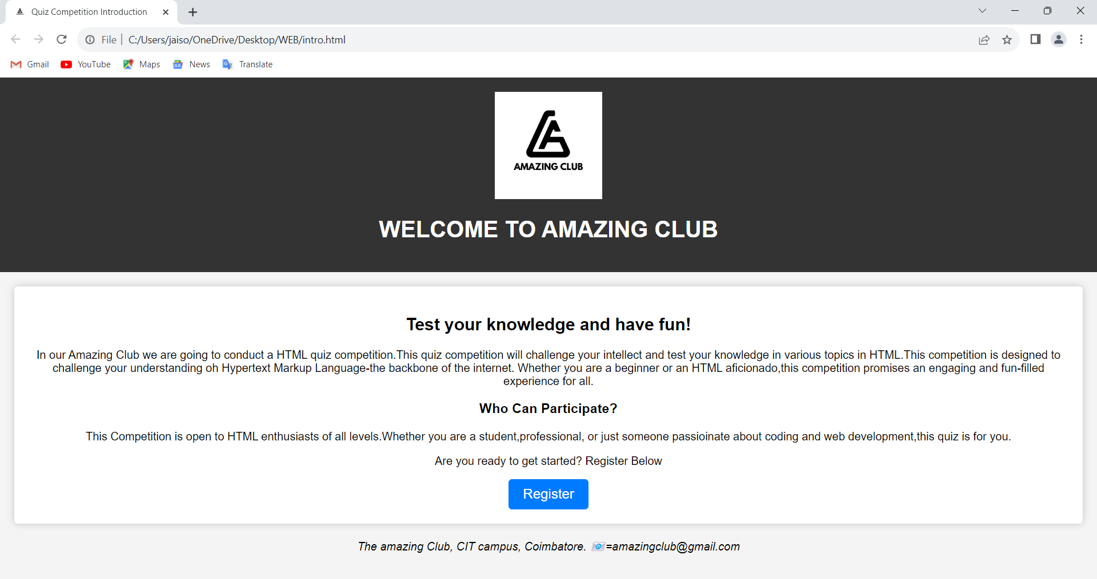
REGISTRATION FORM:


QUIZ LOG IN PAGE:

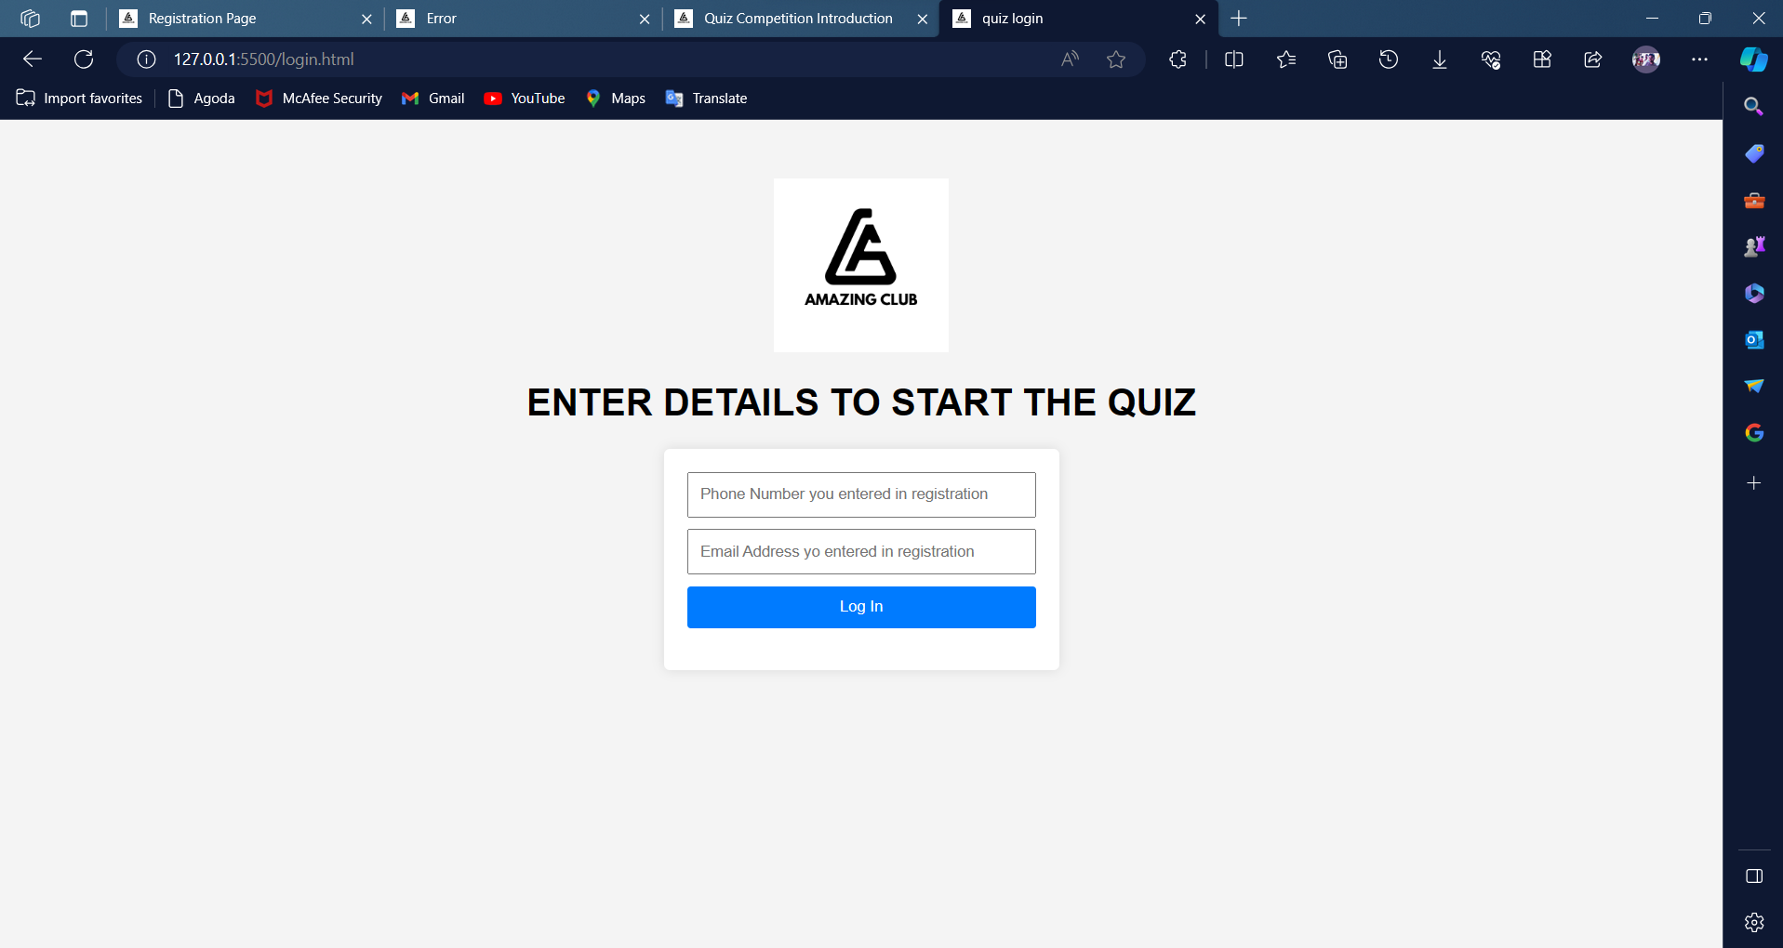

HTML QUIZ:
